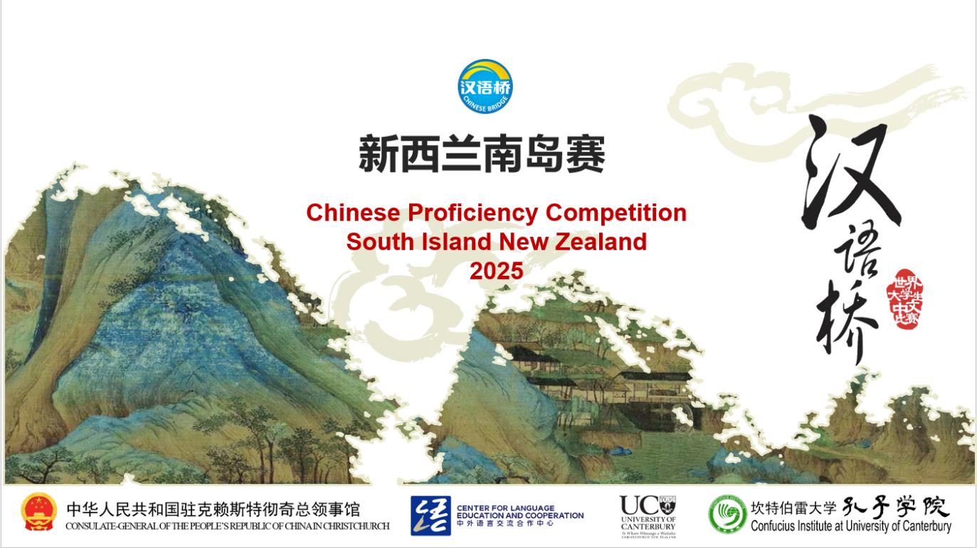

**The 24th “Chinese Bridge”**

**Chinese Proficiency Competition for Foreign Tertiary Students**

**The South Island Regional 2025**

The "Chinese Bridge" Chinese Proficiency Competition aims to inspire students' enthusiasm for learning Chinese and enhance their understanding of Chinese language and culture.

**Category:**

Tertiary Students Category (18-30 years old)

**Eligibility of Participants:**

According to the regulations set by the Centre for Language Education and Cooperation, students representing New Zealand in the International Competition in China must meet the following criteria:

i. Be a New Zealand citizen or New Zealand permanent resident (non-Chinese citizenship).

ii. Have been raised in countries or regions outside of China.

iii. Do not have Chinese as their first language, with neither parent being a native Chinese speaker.

iv. Be a full-time tertiary student enrolled at a tertiary educational institution in the South Island.

In principle, participants from the previous global finals are not allowed to participate in the same category of competition for two consecutive years.

For any questions regarding eligibility, they should be addressed to the organising committee (For more information about how to do this, please contact Xiaolu Chen [xiaolu.chen@canterbury.ac.nz](mailto:xiaolu.chen@canterbury.ac.nz)). The organising committee will decide based on the available information. The committee’s decision is final.

**Registration Deadline for Regional Competition: (1st May 2025)**

1. submit the Letter of Authorisation (Attachment 1) to Xiaolu Chen([xiaolu.chen@canterbury.ac.nz](mailto:xiaolu.chen@canterbury.ac.nz)) by 1st May 2025

**Topic:**

**天下一家** (One world, One family)

**Time and Venues**

|  |  |  |  |
| --- | --- | --- | --- |
|  | Time and date | Venue | City |
| Final Competition | 13:30-18:30  Sunday 25th May | University of Canterbury  (Lecture Theatre) | Christchurch |

**Format of the Competition:**

The competition consists of two sections: Chinese Language Speech and a Talent Presentation. Students may wear traditional Chinese costume, or their own traditional costume if desired.

1. **Chinese Speech:** For this section, each student is encouraged to give a speech related to the topic. Students shall not simply read from a pre-written script. Their speeches will be judged according to the content of the speech, presentation, pronunciation, vocabulary and grammar. This section makes up 80% of the total score.

|  |  |  |  |  |  |  |
| --- | --- | --- | --- | --- | --- | --- |
| **Judging Criteria for Tertiary Students Category** | | | | | | |
| **Sections** | **1) Chinese Speech** | | | | **2) Talent** | **Total** |
| **Judging Criteria** | Content  20% | Presentation  20% | Pronunciation  20% | Vocabulary and Grammar  10% | Artistry /Appeal /Complexity  10% | Language Part+  Talent |
| **Percentage** | 80% (Language Part) | | | | 20% | 100% |
| **Ranking Priority** | 2 | | | | 3 | 1 |

1. **Talent Presentation:** Each student is required to choose one performance art, such as singing (preferably) Chinese songs, playing an instrument, dancing, acrobatics, calligraphy, painting, paper-cutting, martial arts, etc. The presentation should last for no more than 3 minutes. This makes up 20% of the total score.

**Awards:**

Prizes and certificates will be awarded according to each student’s ranking in the competition. After the competition, following qualification verification by the Chinese Bridge New Zealand South Island Organizing Committee, one contestant will be recommended to travel to China to represent New Zealand in the Chinese Bridge Chinese Proficiency International Competition later this year, and another winning contestant is allowed to visit China to observe the competition. All expenses for the selected contestants’ travel to China shall be covered by the Organizing Committee of the global competition, with event time and location to be confirmed. These contestants will be notified in writing following the conclusion of the South Island Competition.

For further inquiries, please email Xiaolu Chen, Confucius Institute at the University of Canterbury at [xiaolu.chen@canterbury.ac.nz](mailto:xiaolu.chen@canterbury.ac.nz).

More information about the “Chinese Bridge” Competition is available at <http://bridge.chinese.cn>.

--------------------------------------------------------------------------------------------------------------------------------------

Attachment 1: Letter of Authorisation

Attachment 4: [Questions List for Tertiary Category](https://docs.google.com/document/d/16YiYqTaKcg3xPCqXMoPCS_lxGkOTdfI4Su-FRIo_2_0/edit?usp=drive_link)