Child Assent Form
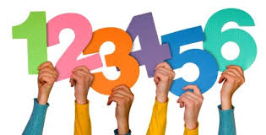

[Name] told me about the project [he/she/they] want to do about [topic]. I know I don’t have to be a part of it if I don’t want to. If I have any questions I can ask [my teacher/ name] or the person who takes care of me.

Colour in the YES circle if you want to take part in the study. Colour in the NO circle if you do not want to take part.
I want to be a part of the project. I want to help [name] learn more about [topic] (OR I want to be a part of the project. I want [name] to help me with [topic].)

I don’t want to be part of the project.

My name: ___________________________________________
Please give this back to your teacher now.

