Hopkins Lecture 2006

*The economy and energy: are both sustainable?*

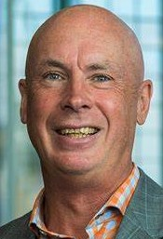



Dr Don Elder

Chief Executive Officer Solid Energy

[www.linkedin.com/in/Don-Elder-NZ](http://www.linkedin.com/in/Don-Elder-NZ)

*This lecture may be consulted for the purposes of private study or research provided that appropriate acknowledgement is made of its use.  Please contact* [*copyright@canterbury.ac.nz*](mailto:copyright@canterbury.ac.nz) *for any queries related to the ownership and use of this work.*