Respondus LockDown Browser FAQ
- Restart the system before a test or if there are any problems and do the practice quiz
- Most error codes can be found on the Respondus website

General

What is Respondus Lockdown Browser?
Respondus LockDown Browser and Respondus Monitor function as a restricted web browser, which interacts with AKO|LEARN to deliver assessments and examinations in order to prevent breaches of academic integrity.
Respondus LockDown Browser by itself creates a locked down machine environment; whereas Respondus Monitor adds an additional layer of invigilation to the locked down machine by recording the assessment/exam session using the web camera and microphone of the device.

What are the system requirements?
 | Windows | Mac | iPad | ChromeOS
Version | 11 and 10* | macOS 10.12 to 12.0+ | 11.0+ | ChromeOS 88+
Memory | 2 GB RAM (minimum 4gb of available RAM is necessary when using LockDown Browser to take an exam that also uses a webcam.)
Hard disk space | 200 MB
* Includes x86 32 and 64bit processors and ARM 64bit processors using x86 emulation.
* Windows 10S is not a compatible operating system.

LockDown Browser and Respondus Monitor may continue to run in older operating systems that have reached “end-of-life” but students may encounter unexpected results.

Does Respondus work on wi-fi?
Respondus will work on a wi-fi connection but an ethernet connection is recommended over Wi-Fi where possible.

Students can book rooms in the Library to take tests and exams if they do not have access to a reliable internet connection.

Can students located in China use Respondus?
Students in China will need to use a VPN to be able to do a Respondus quiz.
VPN Client Set up Guide (Overseas Students Only)

Must students do the Respondus practice quiz?
It is highly recommended that students attempt the Practice Quiz which they will find loaded on their AKO|LEARN site.

Attempting to complete the Practice Quiz will:
- prompt students to download Respondus LockDown,
- test that their device is compatible with the Respondus software, and
- get a feel for what the Respondus interface is like.
Students can do the Practice Quiz as many times as they like.

LockDown Bowser has stopped responding?
- A loss in Internet connection while taking an exam or outdated and/or multiple Java installations, may cause LockDown Browser to stop responding or freeze.
  - A hard reboot may be needed.
  - If after the hard reboot, the Start Menu or Task Bar is missing or the Task Manager cannot be accessed, restarting the LockDown Browser and exiting the software properly should resolve this.

- A blank page fills the screen
A security window may have popped up behind the LockDown browser.
    - If the student has not started the exam yet, close the browser and address the security pop-up windows
    - If the student has started the exam, restart the computer and address the pop-up windows before beginning the exam.

“Video connection has timed out”?
Try the following if students encounter the "Video connection timed out" error

Who to contact when there is a problem?

Windows

Respondus Monitor won’t start?
- Confirm that LockDown Browser is allowed in the privacy settings for the camera (in Windows, camera utilities or anti-virus software) and microphone.
- Confirm that no other applications have control of the webcam or microphone.
- Consider ‘rolling back’ to a previous version of a driver that worked.
- Try an external USB webcam.

Screencastify error?
Screencastify is a Google Chrome extension (typically). The LockDown Browser session will not
open until you disable or uninstall it.
1) Remove the Screencastify extension completely.
2) May also need to remove any user data that is cached.
3) May also need to remove Google Chrome, then re-install Chrome.

Power options missing, can’t use Ctrl + Alt + Delete and no Task Manager
This particular problem occurs when LockDown Browser is not shutdown properly. In some cases, it’s another application (e.g. security or antivirus software) or permissions on the Windows account being blocked or corrupted that causes LockDown to not shutdown properly.
Suggested options to try:
- Restart the computer, don’t load any other programs, go straight to Learn and attempt a practice quiz (locking the screen or putting the system into sleep mode might allow the restart option)
- Try Restoring default settings after a power down
- Create another admin user account on the system to identify if it’s a permissions issue

Mac

Mac scroll bar is missing?
Go to System Preferences > General. Change "Show scroll bars" to "Always" as shown below.
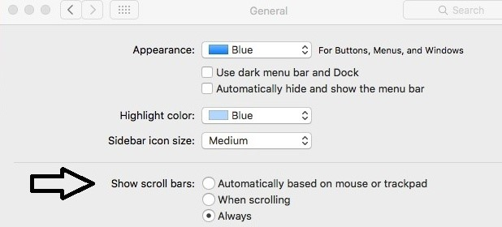

Need to close ‘Applevncserver’ or ‘ARDAgent’?
LockDown Browser offers to try to stop these programs but is unable to do so.

Go to Finder -> System Preferences -> Sharing and uncheck Screen Sharing, Remote Login, Remote Management and Remote Apple Events to avoid the warnings.

Siri detected as running on Mac?
- Try clicking the "kill these applications" button repeatedly
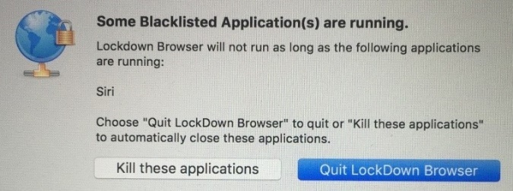
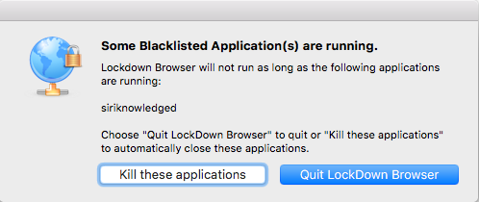
- Verify that the student is logged in as the "primary user" and that no other accounts are active

Google Chrome OS

Google Chrome OS can't open the page?
- The LockDown Browser for Chromebook extension is not installed.
- The extension is installed, but disabled.
- Cookies or cache need to be cleared.

